IT4Innovations project evaluation form

All investigators who were allocated the computing time within the Open Access Competition are kindly requested to fill out this form. Submitting the filled-out form is mandatory to meet the conditions of the project termination and reporting.
Your research results reported in this form are expected to be further presented at IT4Innovations website/newsletter, or in other IT4I public relations materials.

Name of the project: Low dimensional magnetic systems
Project ID: IT4I-2-2

Name and surname of primary investigator: Dr. Dominik Legut

Affiliation of primary investigator: IT4Innovations, VSB-Technical University of Ostrava, Ostrava (senior researcher)

e-mail: dominik.legut@vsb.cz

Research area: condensed matter physics, first-principles calculations

Abstract of achieved results for PR use:
The main aim of this project is a search for the new technology of data recording, e.g. hard-drives. Current industrial technology is based on an effect of a huge electric resistance upon applied magnetic field. This requires a multi-layered structure of magnetic materials that are commercialized for read/write heads of the hard-drives, sensors for acceleration and for bearings detecting small magnetic fields. This research lies in imitation of the multi-layered systems by using compounds that exhibit one- or two- dimensional magnetic ordering. We focus on understanding the fundamental aspects of the low-dimensional magnetically ordered systems, where number of competing phases with different magnetic ordering and therefore physical properties occur. Namely, we determined the thermodynamic stability, magnetic behaviour, mechanical and optical properties. If we understand the existence of magnetically frustrated materials the new higher-density hard-drives and other magneto-recording media could be designed.

Graphical abstract of achieved results for PR use:
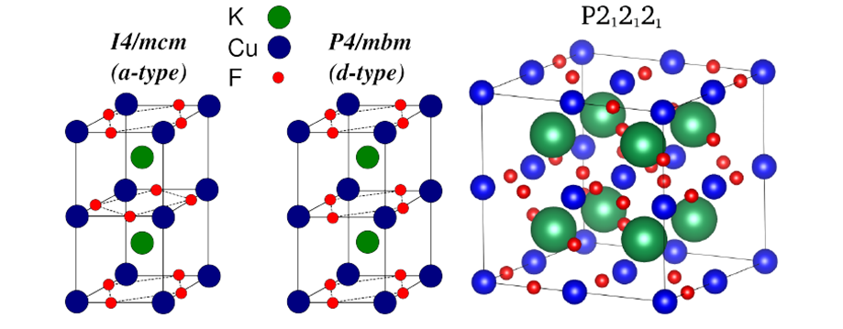
Possible magnetic orderings in three different phases of the one-dimensional antiferromagnet of KCuF_{3.} In both tetragonal phases (I4, P4) different stacking of F atoms leads to change of the properties, IR spectra, Neel temperature etc. At higher temperature the orthorhombic phase (right) was also reported.

Summary of scientific results:
In Ref. [1] we have calculated the energetic stability of two tetragonal and one orthorhombic phase of KCuF₃ – at low temperature a one-dimensional magnetic system. The zero-point motions plays significant role in energetic stability indicating that the orthorhombic phase is the least stable. From calculated lattice dynamics we identified Raman and infrared active modes (vibrations) and frequencies at which the single phases could be clearly determined if both phases are present in sample. Based on the calculated mechanical properties of all three structures the orthorhombic one suffers from brittle fractures under a shear/tensile load in contrast to the ductile behavior of tetragonal phases of KCuF₃ [2].

List of publications (published, accepted(A), submitted(S)) / patents:
1. D. Legut and U. D. Wdowik: Vibrational properties and the stability of the KCuF₃ phases, J. Phys. Condens. Matter. 25, 115404 (2013).
2. D. Legut and U. D. Wdowik: Mechanical Properties of Tetragonal and Orthorhombic Phases of Quasi-One-Dimensional Antiferromagnet KCuF₃, Acta Phys. Pol. A (A)

Computational experience – Pros and Cons of computing at Anselm:
Computational approach, parallelization and scalability:
The scalability of Wien2k software is at the moment not linear on single nodes using 4, 8, 16 cores utilizing a serial subroutines of the code (per core) written in Fortran 90 and compiled with default intel compiler, mkl libraries and using scalapack.
1node-4cores only
real 39m33.245s
user 2m7.530s
sys 0m27.330s

1node-8cores only
real 21m56.167s
user 2m3.300s
sys 0m32.670s

1node-16 cores:
real 17m37.181s
user 2m27.310s
sys 0m56.120s
This is for us a serious concern as the code runs in serial mode over the number of sample point (k-points) in Brillouin zone that each runs on one single core. Further investigation of the problem is under way, but would benefit from the cluster support service.

Suggestions to improve HPC at Anselm
To allocate at least one node for single long-term jobs, i.e. longer than a week. I have a post-doc, who has such a code, and he will benefit, if one node could be like this.

